

MARKETPLACE

* DEMAND API -

# HERE Mobility Platform Overview

HERE Mobility aims to democratize the mobility ecosystem. We are creating a competitive marketplace powered by intelligent technological solutions for all mobility service providers, businesses, and consumers.

HERE’s central platform is the **HERE Mobility Marketplace**, a hub for supplying and requesting mobility services, for businesses and consumers. The Marketplace enables matching up end users with suppliers who can meet their needs for transportation and delivery.

The **HERE Mobility Demand API** is a REST or GRPC API that enables the customer application to request, book and cancel mobility services. Demand API requests are sent to the HERE Mobility Marketplace, which matches up ride requests with available suppliers, and manages ride information and statuses.

# Introduction to the Mobility Demand API

## What is the Demand API?

The Demand API enables the calling application to request, book and cancel mobility services. Here are some examples of possible client applications:

* A smartphone app, which a private customer uses to book a taxi ride.
* A public kiosk device located at a business, such as a mall or hotel lobby, which provides mobility services to multiple customers.

End users can request a ride while defining any special needs they may have, such as number of passenger or suitcase storage. Users can also request to sort the ride offers by price or ETA (Estimated Time of Arrival). They can view several ride options, choose the one they want, and book it. If the supplier’s policy permits, rides may be cancelled after they’re booked. Once a ride is booked, the passenger can get real-time updates about the supplier’s status (on the way, at pickup location, and so on).

**Notes**:

* Currently only taxi suppliers (full integration) and public transportation(planning stage) are supported.
* The passenger’s location is stated in the ride request, and accordingly only rides from nearby suppliers are offered.

## Technical Specifications

The Demand API is a supported over the REST and GRPC protocols.  
  
REST endpoint:

<https://demand-rest.inc-stg.solo-experiments.com/>

GRPC endpoint:

<https://demand-grpc.inc-stg.solo-experiments.com/>

**Note**: For a single client, requests to the Demand API must be limited to a rate of 50 requests per minute, and a total of no more than 1000 per day.

## The Consumer-to-Service and Service-to-Service APIs

HERE supports 2 versions of the Demand API:

* **The Consumer-to-Service API** – meant to be called by a client application that supports a single end user, such as a mobile phone app.
* **The Service-to-Service API** – meant to be called by a client application that supports multiple end users, such as a public kiosk device.

The 2 APIs are nearly identical in terms of syntax and workflow. The main difference is that the service-to-service request messages contain an additional user ID parameter, to enable managing rides for several users. Calls made to the consumer-to-service API are all assumed to refer to the same single user.

## Getting started

Here mobility account creation  
To create your account at Here mobility contact: mobility_developers@here.com.  
with your full name and email address, you will receive an initial password and verification email to your mailbox.  
On a later stage, you will be able to manage your account via our Here mobility developer zone.  
  
Obtain application credentials   
To obtain application user credentials for the Demand API, contact: mobility_developers@here.com.  
Please specify the following:

* Application name
* A URL for a web application or a package/store ID for a mobile app

You will receive an:

* Application key
* Application secret value

Here is an example of what the application key and secret values look like:

{

    "applicationKey": "Casd9nS4WUs90***cCvsurYgtpLEgm8",

    "applicationSecret":

           "QcVyN7Wq3HNqWN3DEAI0H***mibtsdUkJ_8zS0skrRHfZyzKbW0gmvjSKgnLt"

}

**Note**: For security reasons, the applicationSecret value must not be exposed to the end user. Store the applicationSecret value in your server-side code and not in your client-side code. If any abuse of the applicationSecret is detected, your credentials will be revoked.

Authenticating App users

In order to use Here Mobility Demand API on behalf of your users, from security reasons, you need to sign their username with the Demand API App key and App secret.

C2S Token  
On C2S API, the recommended procedure is to have your backend server do this when the user logs in, and send the signed "hash" to the app. Once the app has the hash, it should be passed to the Demand API.

Method: GET

URI: /accounts.v1/application/c2s/token?application_key=<application_key>&user_id=<user_id>&expiration=<expiration>&hash=<hash>

* Application Key & User ID : are plain strings (not converted to Base64 like when feeding them to the hash function)
* Expiration: tells us when the authentication (in seconds, since Epoch) expires.

S2S Token

Method: GET

URI: /accounts.v1/application/s2s/token?application_key=<application_key>&application_secret=<application_secret>

## Using the HERE Sandbox Platform

You can use the HERE Mobility Sandbox platform to develop and test your app’s functionality without calling the production platform. Requests to the sandbox environment are ephemeral (do not actually affect the real world).

The HERE Mobility service directs your app’s calls to the sandbox or production environment according to the API key you provide.

# Common Workflows

The diagram below illustrates the workflow for booking a ride and updating its status during the ride.

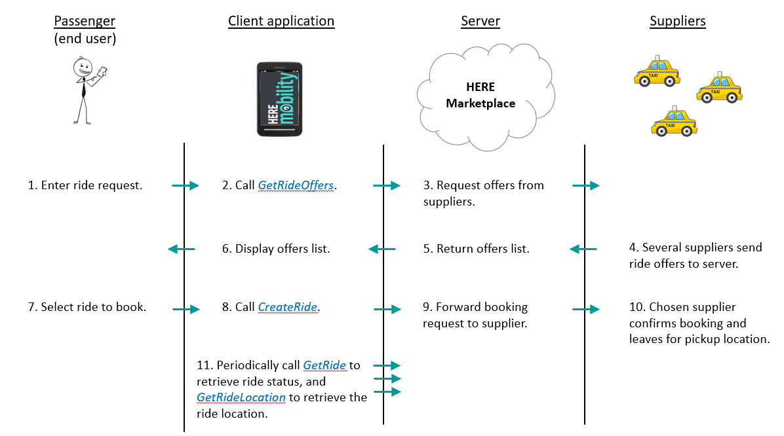

Figure . Workflow: Booking a Ride

The following sections describe the Demand API calls that the client application makes when implementing common mobility workflows.

## Requesting and Booking a Ride

To request and book a ride:

1. Call GetRideOffers. In the RideOffersRequest parameter, the client specifies the passenger details, pickup and dropoff locations, and any special requirements such as a child seat. Optionally, the client can specify a future pickup time, a desired price range and a sort order for the returned ride offers.
2. Receive a RideOffersResponse object. This is a list of RideOffer objects, containing details such as supplier ID, price, ETA and cancellation policy. If a sort order was specified in the request, the offer list is sorted by the order requested (lowest to highest price, or soonest to latest ETA).
3. The passenger selects one of the offers.
4. Call CreateRide, passing a CreateRideRequest object that contains the chosen offer ID. Receive a Ride object.

**Note**: This workflow may be repeated as necessary, if a booking request fails.

## Getting the Ride Status

Ride objects have one of the following status values:

|  |  |
| --- | --- |
| **Status** | **Description** |
| UNKNOWN | Unknown status |
| PROCESSING | Looking for a supplier |
| REJECTED | The supplier cannot fulfill the ride request |
| ACCEPTED | The supplier accepted the request; a driver is not yet assigned |
| DRIVER_ASSIGNED | A driver has been assigned to the ride request |
| DRIVER_EN_ROUTE | The vehicle is en route to the pickup location |
| AT_PICKUP | The vehicle is at the pickup location |
| PASSENGER_ON_BOARD | The passenger is onboard; the vehicle is en route to the dropoff location |
| AT_DROPOFF | The vehicle is at the dropoff location |
| COMPLETED | The ride was completed successfully |
| CANCELLED | The ride was cancelled by the supplier or by the client. |

The client application can poll periodically to get the current ride status, in order to display it to the end user.

To get the current ride status:

Call GetRide. This returns a Ride object that contains several ride details, including its status.

## Getting the Ride Location

You may want to poll periodically for the ride location, so that you can display it dynamically on a map.

To get the current ride location:

Call GetRideLocation. This returns a RideLocation object that contains the ride’s geo-location, and optionally the estimated time of arrival at the pickup or dropoff location.

## Cancelling a Ride

To cancel a ride after it was accepted:

Call CancelRide.

**Note**: This call may fail if the booking is not active, or if the supplier’s policy doesn’t allow cancellation.

## Reviewing Rides

The end user may want to review past rides, future (pre-booked) rides, or rides are currently active.

To retrieve rides by their status (and optionally by their last update time):

Call GetRides.